MATLAB analysis for vesicle numbers and distance to the MTOC

*MS ID#: JOCES/2019/235192*

*MS TITLE: B cells rapidly target antigen and surface-derived MHCII into peripheral degradative compartments.*

**Script by Andreas Bruckbauer.**

**Instructions:**

All Matlab scripts were done in Matlab R2017b. Image analysis toolbox is needed. Additionally the script uses the bioformats matlab toolbox to load and save the files. This has to be installed, downloaded, unzip and add to Matlab toolbox folder and Matlab path. You might also need to increase the Java heap memory in the Matlab preferences (home tab) under General\Matlab Heap Memory.

The scripts should be saved in the Matlab folder.

# Script -1: Cropping cells (to cut individual cells from tiff files for analysis)

Name: Cut_cells_deconv.m

Define directory to read files from: Copy here the path of your files.

main_dir = 'C:\';

Define directory to save files to: Copy here the path where you want to save your files.

save_dir = 'C:\’;

Define a name for the experiment, will be added to results files (example: ‘5 minutes’):

experiment = ‘Your name’;

Define file extension (in our files, we have the extension cmle.tif after deconvolution. Change this accordingly).

regex = 'cmle.tif';

The parameters to change are the display adjustment

display_adjust1 = 0.2; % for display only

display_adjust2 = 0.03; % for display only

The lower the value, the brighter the image

And the size of the square of the image to cut in micrometre

cell_size = 10; % approx size of cells to determine square region

The first two files in the directory have to be the files for channel 0 (antigen, C0) and channel 1 (MTOC, C1). Rename your files accordingly.

It takes time to load the files, you will see the two images (first one and then also the second one):

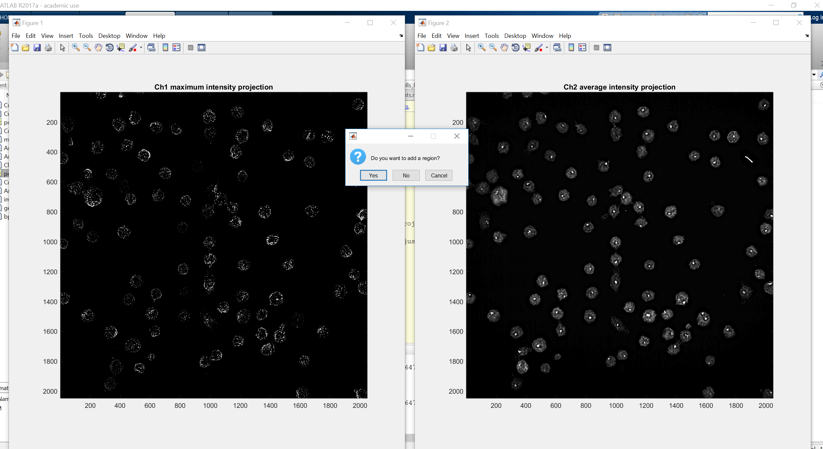

If you click “yes”, you see the square region and can move it around with the mouse, **double click to select the cell**, then you can add another one. To exit, click “no”.

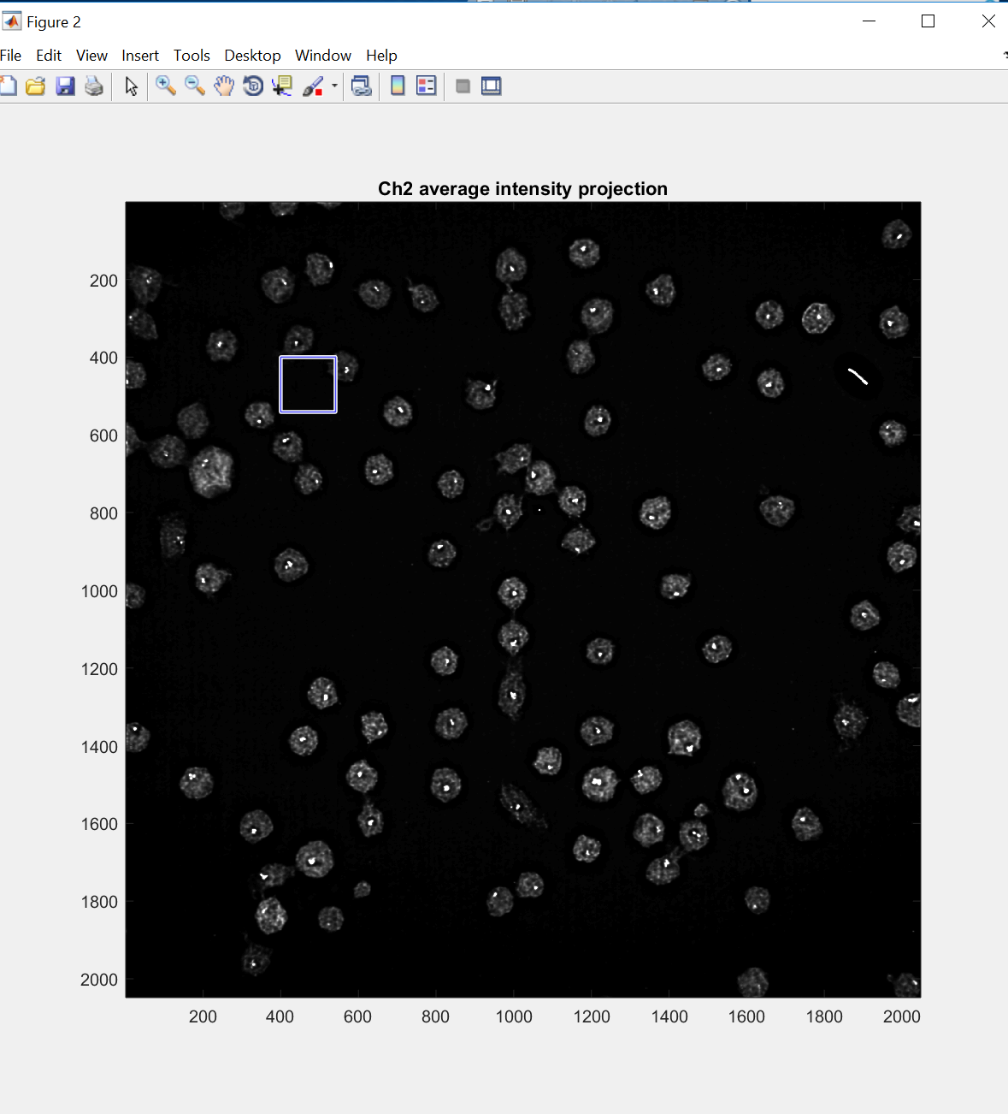

Once you select ‘No’ the script, the script will save the image with the selected regions in the folder that you set at the beginning (save_dir).

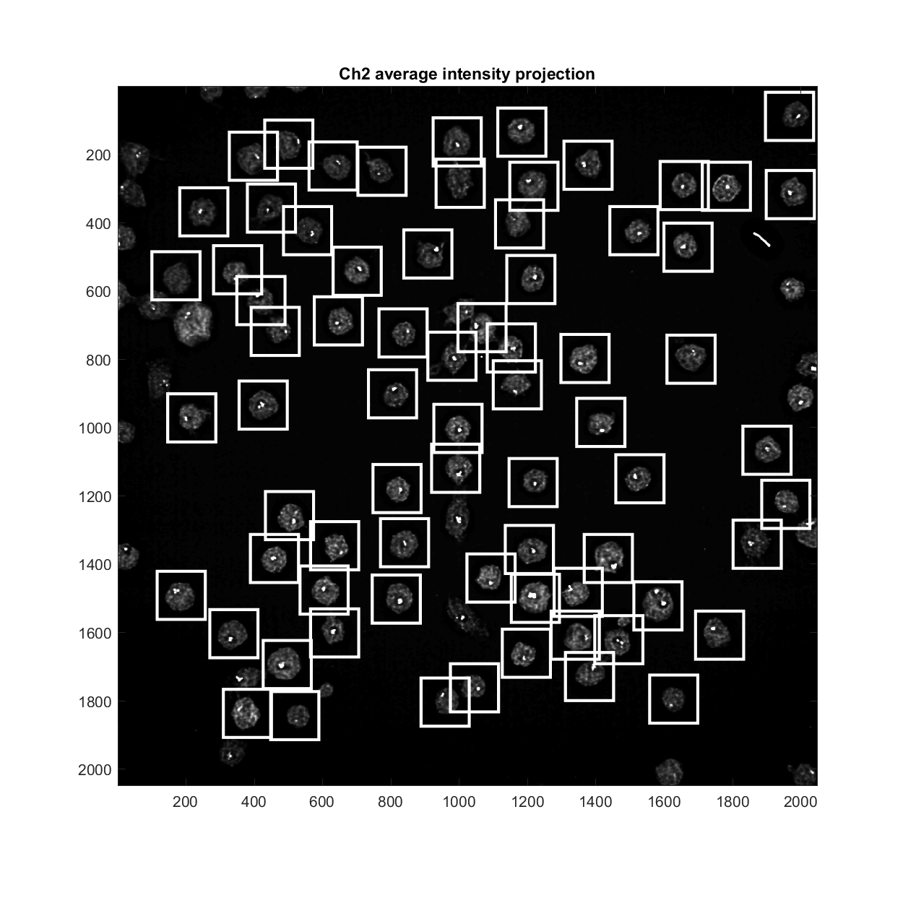

Then it will go through the positions, display a 2 color projection image and crop the data. The data is saved in OME.TIFF format. If loading these files with Fiji, bioformats importer is required to display the images properly. The individual 2 color images are also saved (in the main image folder), you can go through them and decide which cells to delete, the cell number is displayed in the title.

# Script-2 – to identify vesicles and measure distances

Name: Analyse_ROI_data.m

Define directory where the cut files are in and experiment name.

data_dir = 'C:\’;

experiment = ‘Your name’;

These two parameters are important:

var_threshold_1 = 0.7; % for cluster detection, 1 = Otsu threshold

var_threshold_2 = 1.0; % for MTOC detection, 1 = Otsu threshold

You can influence the automatic thresholding, the lower the number, the lower the threshold and dimmer clusters will be selected, but also brighter clusters will coalesce to larger ones.

*The distance threshold filters out cluster which are close to mtoc*

*distance_threshold = 2; % cutoff for central cluster counting in micrometer*

*This is only used at the end of the script to calculate the average number of central clusters*

When starting the script the first cell will be displayed and you can choose if you want to analyse the cell via a dialog box, if you choose ‘Yes’ you can manually change the auto-threshold with a tool:

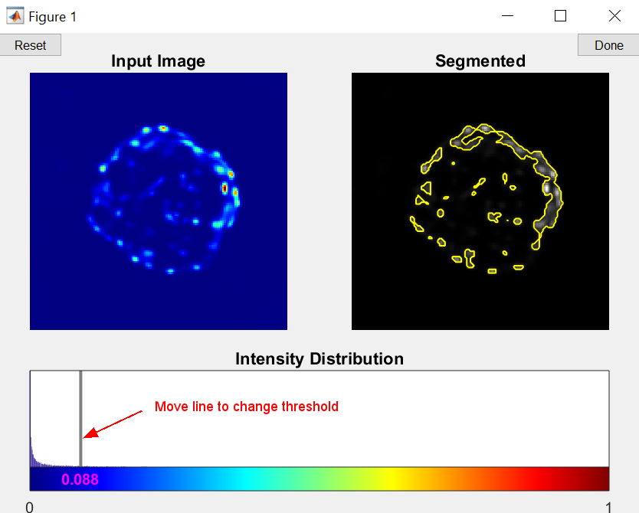

This is done on a maximum intensity projection of the image, the segmented area is shown (yellow lines), in the image above several clusters are combined to a large area. This is how it looks like with a higher threshold:



Click the ‘done’ button (top right) when finished.

Next you see the cell and a circle which you can move and change in size to select cell of interest, then double click to select.

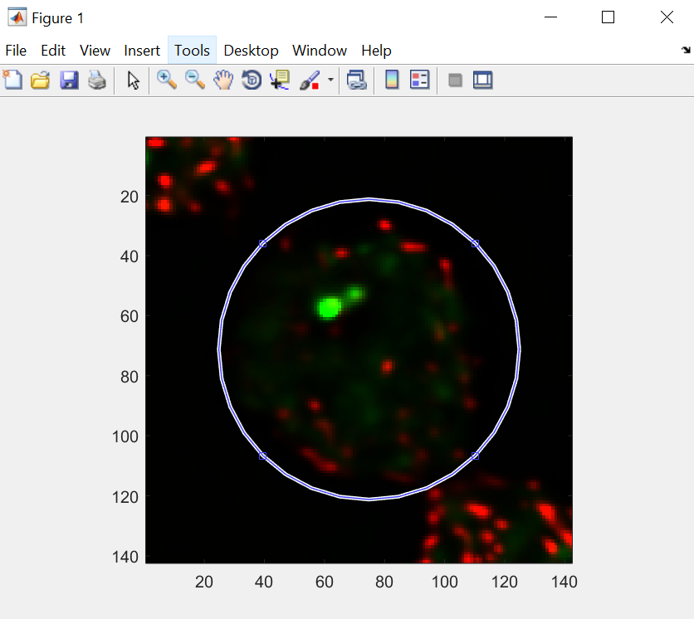

The program displays a maximum intensity projections with the identified clusters (red circles) and mtoc and plots lines between them to illustrate the distances. **The analysis is done in 3D and the correct 3D distances are calculated. You can set**

show2D = 1;

this shows a sequence of 2D segmentations for the different z-sections.

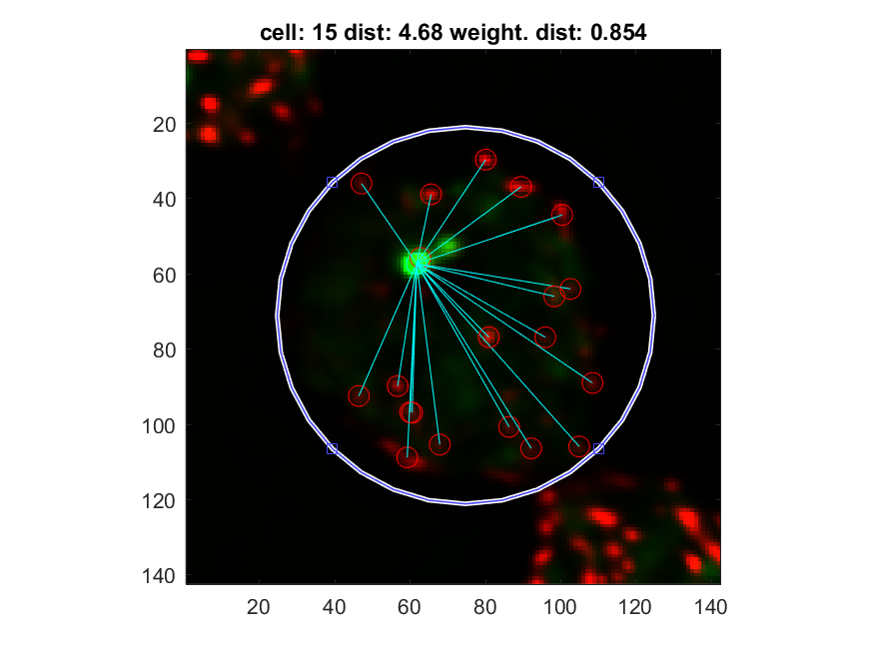

The image is saved as PNG file. The file name will have the original file name in it, so you can follow back to the ome.tiff file where it originates from (the cell number might have changed from the one in the first script due to the way the files are sorted).

The main output is a matlab file and a two text files. **They start with the experiment name and end with _deconv_all_values.txt for the file which has the distances and intensities of all vesicles** and _deconv_results.txt which has only the file names and the average results. The first file can be imported to Excel when comma is used as delimiter, it also includes the file names and the total cluster intensity of all clusters in the cell. Using the excel file, the number of vesicles per cell and the mean distance of the vesicles to the MTOC in that cell can be calculated.